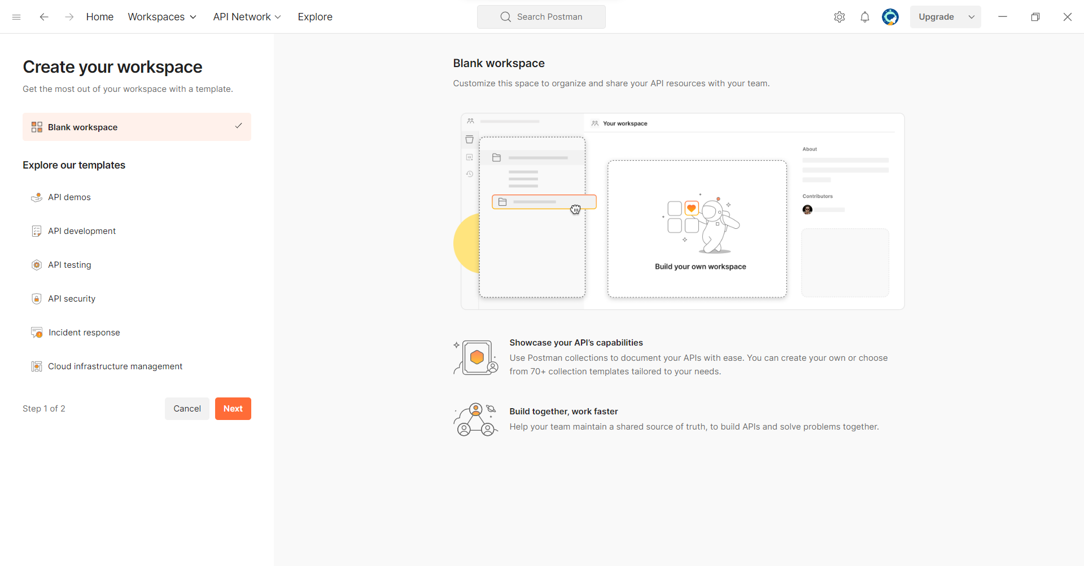

Creating a workspace for Weather report

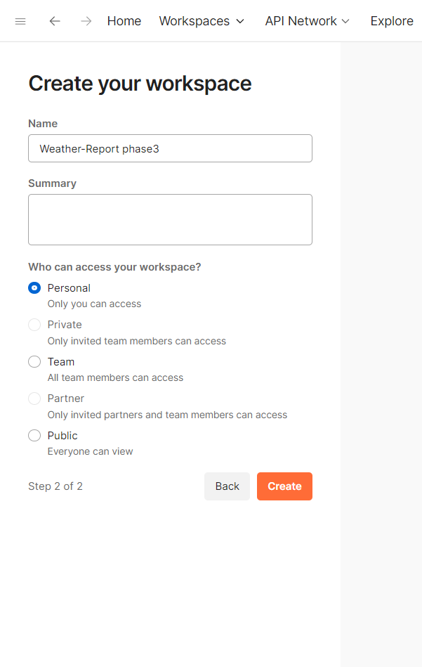

Clicking on + button to add collection

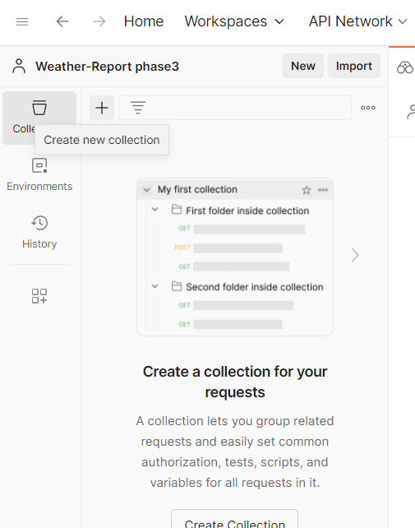

Selecting blank collection

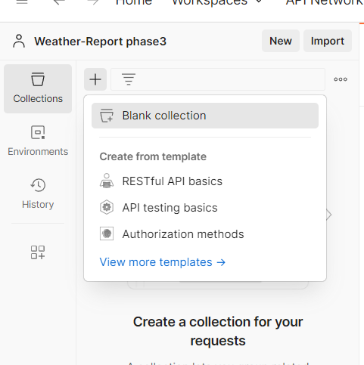

Created a collection named as parameter-weather report

And click on the three dots

And selected add request.

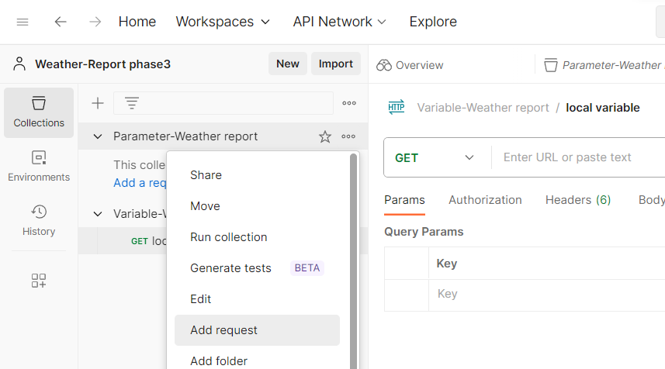

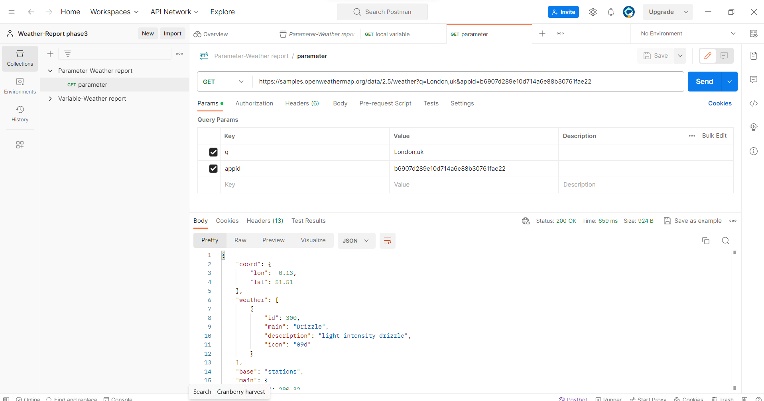

Enter the url.select GET method. in params the key and value are appears once it is saved

Then click on send to the view the request.in down the result is appeared in the pic.

Click on send button to see the output.

Then click on the collection to add another request for types of variables

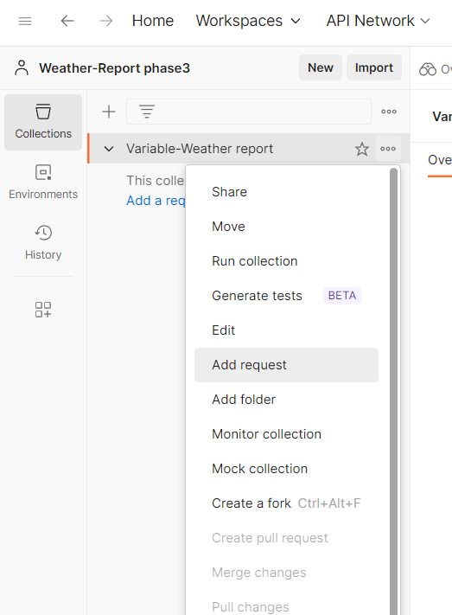

Request name=local variable

Method=GET Method

In pre-request script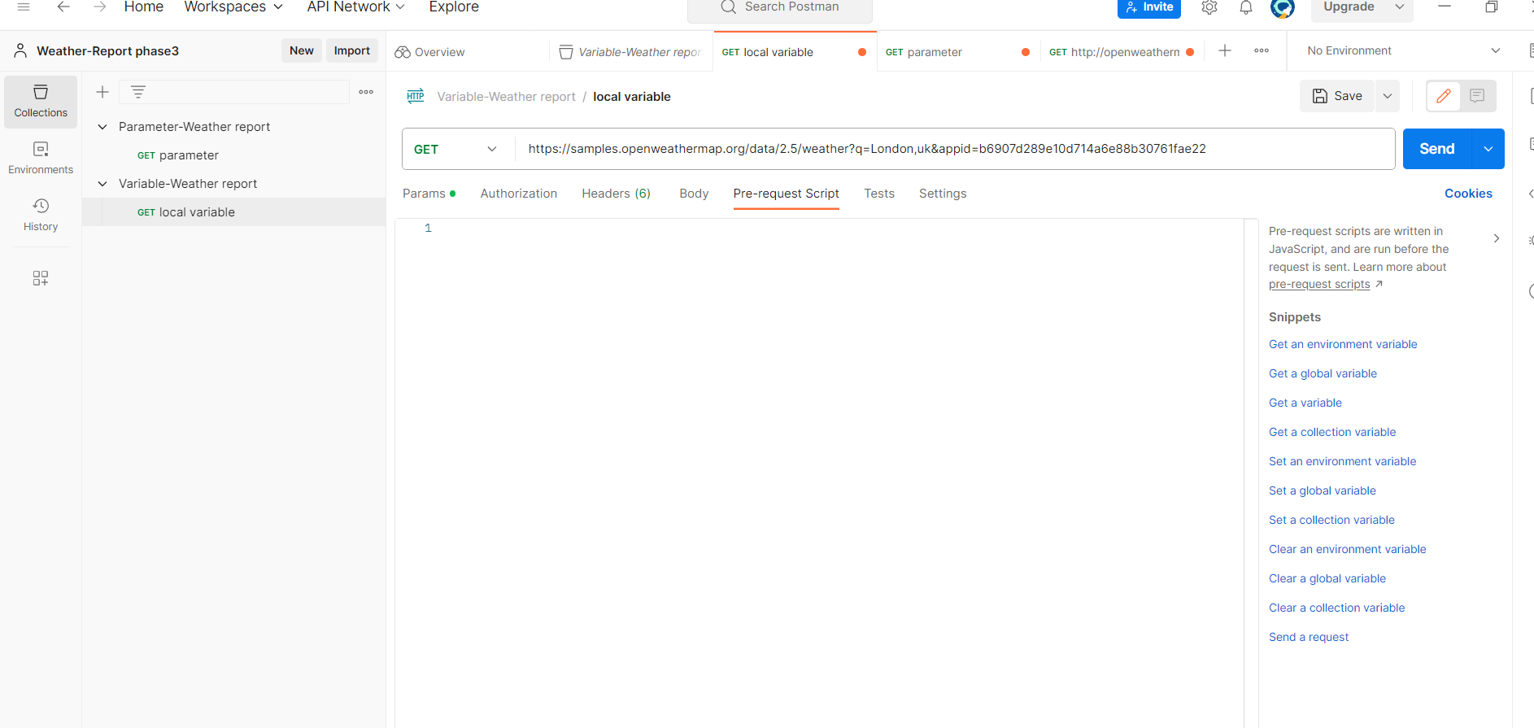

We set a local environment variable.

City=Hyderabad

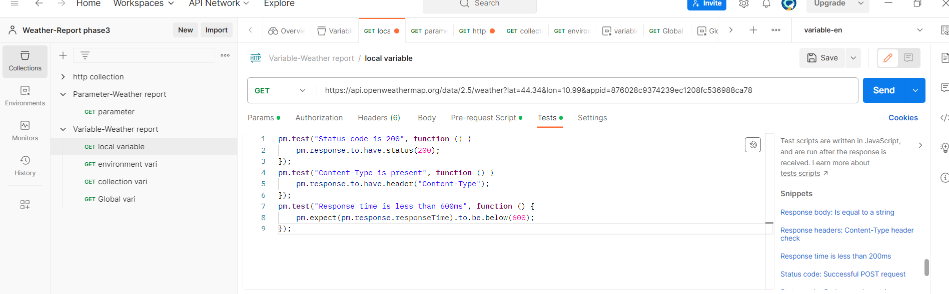

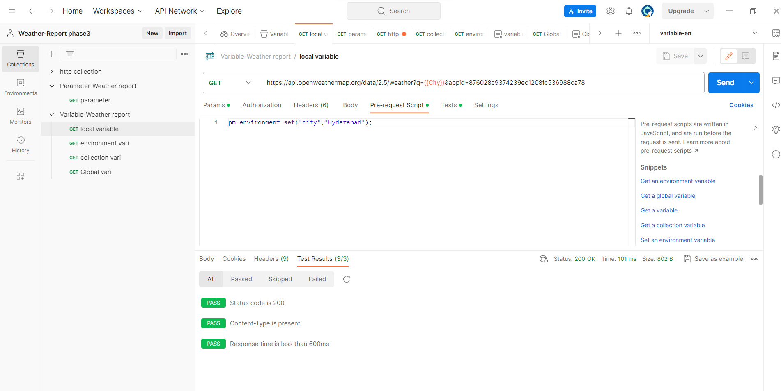

**Collection variable**

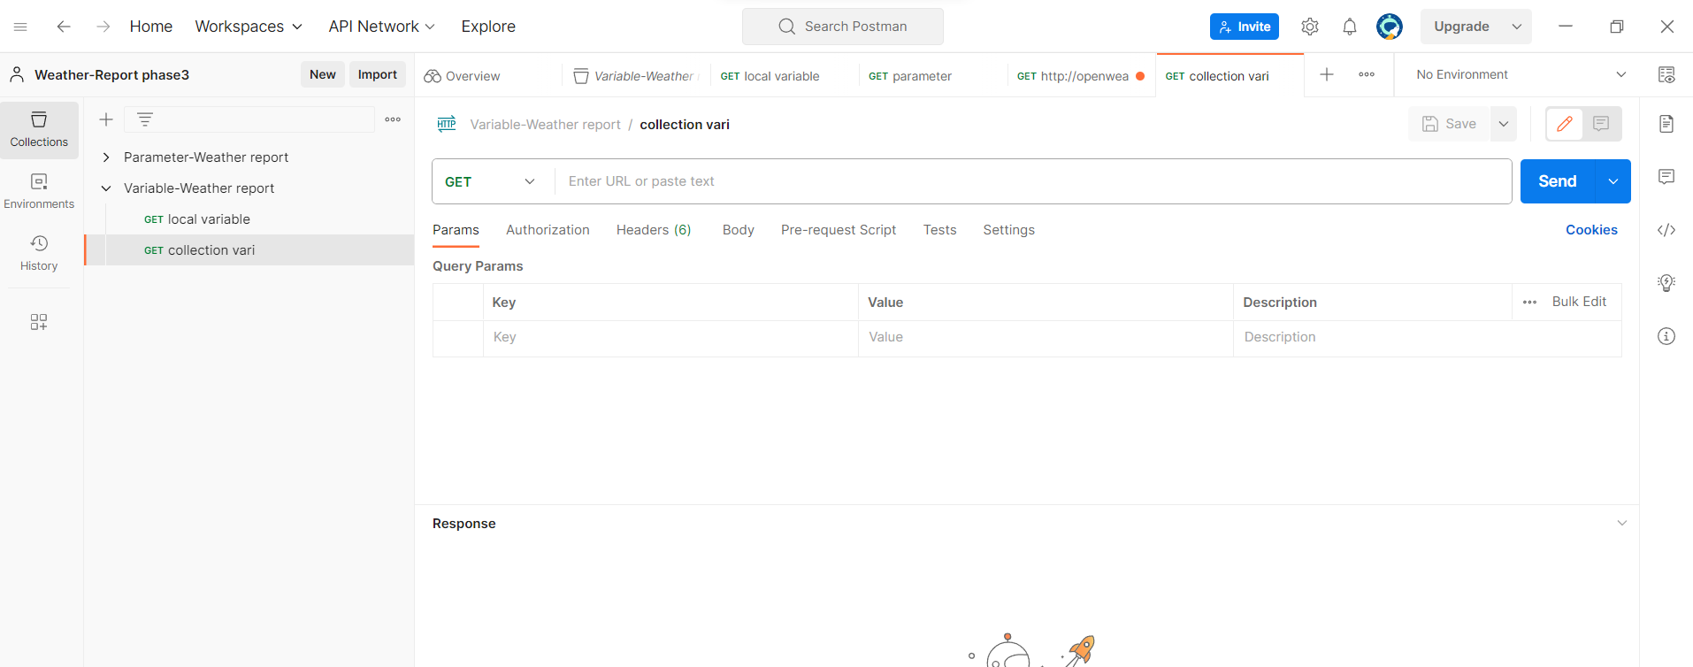

In collection ,we set the collection variable

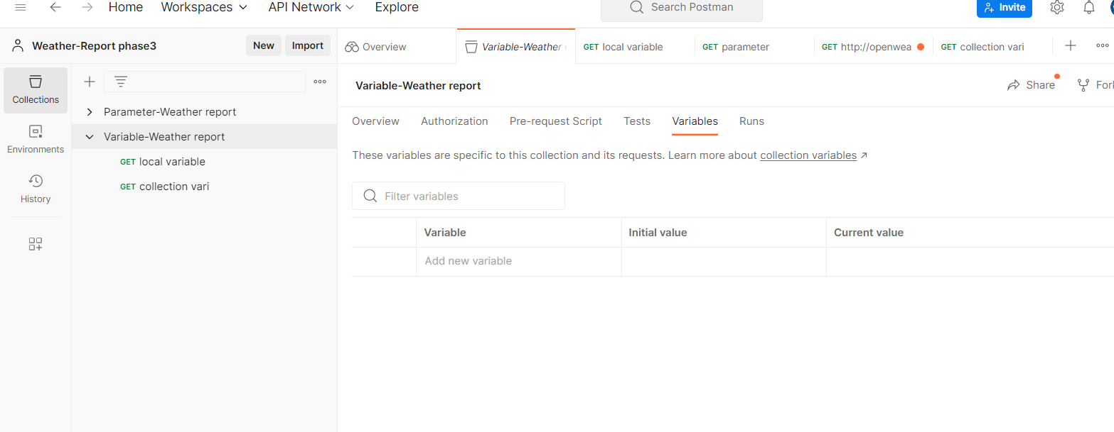

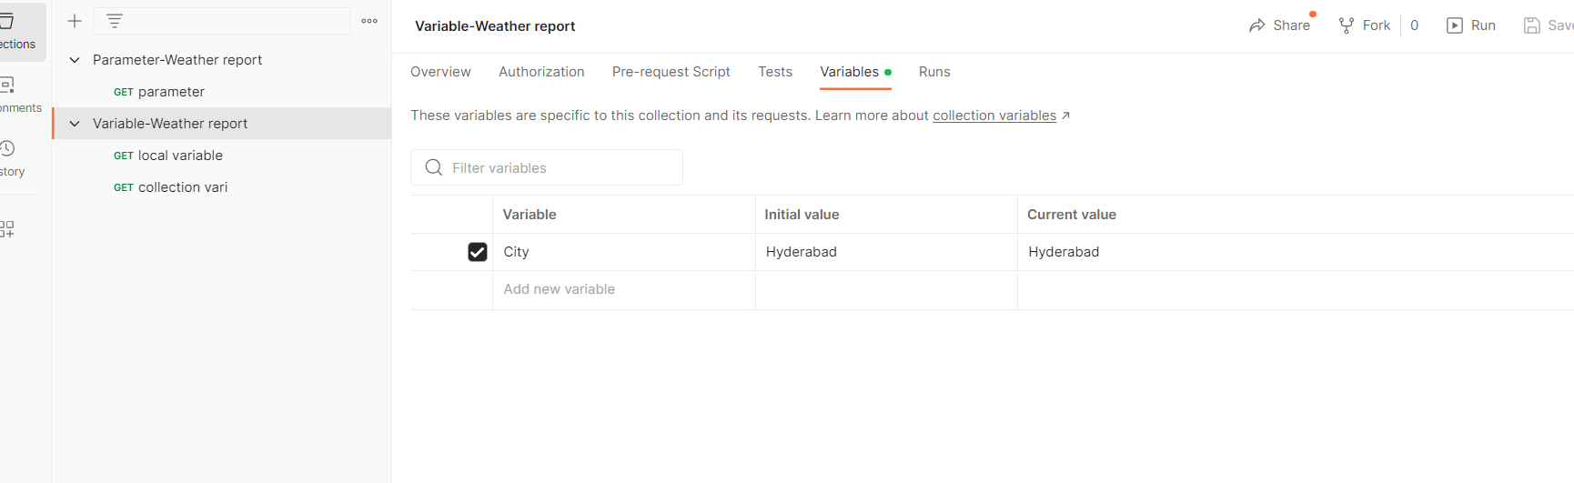

in test we added

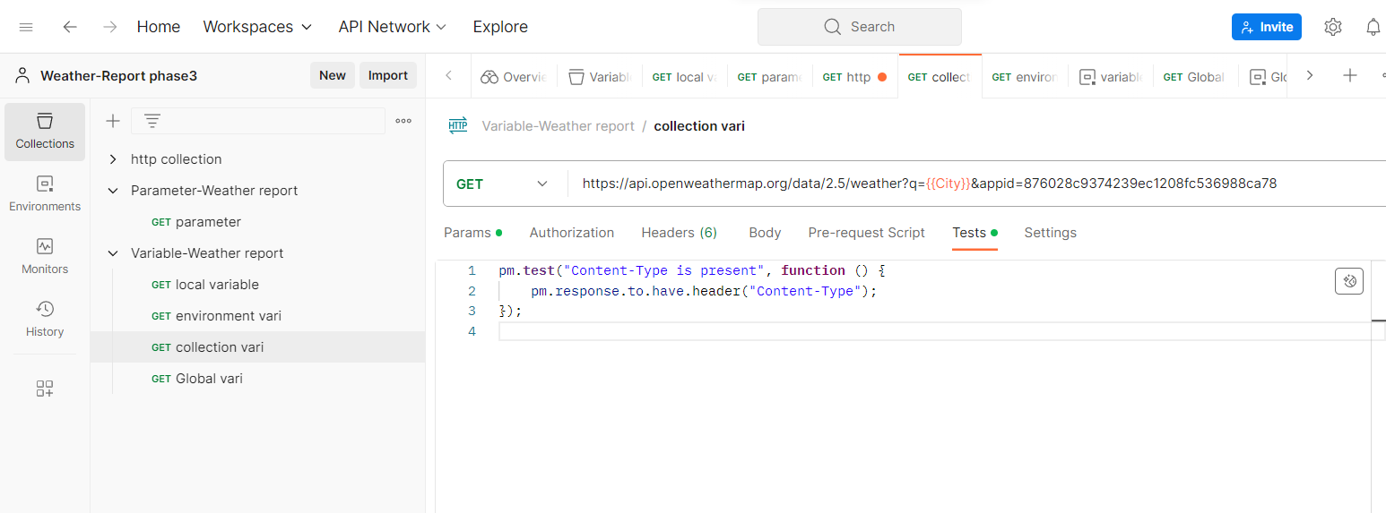

**Click on send button.**

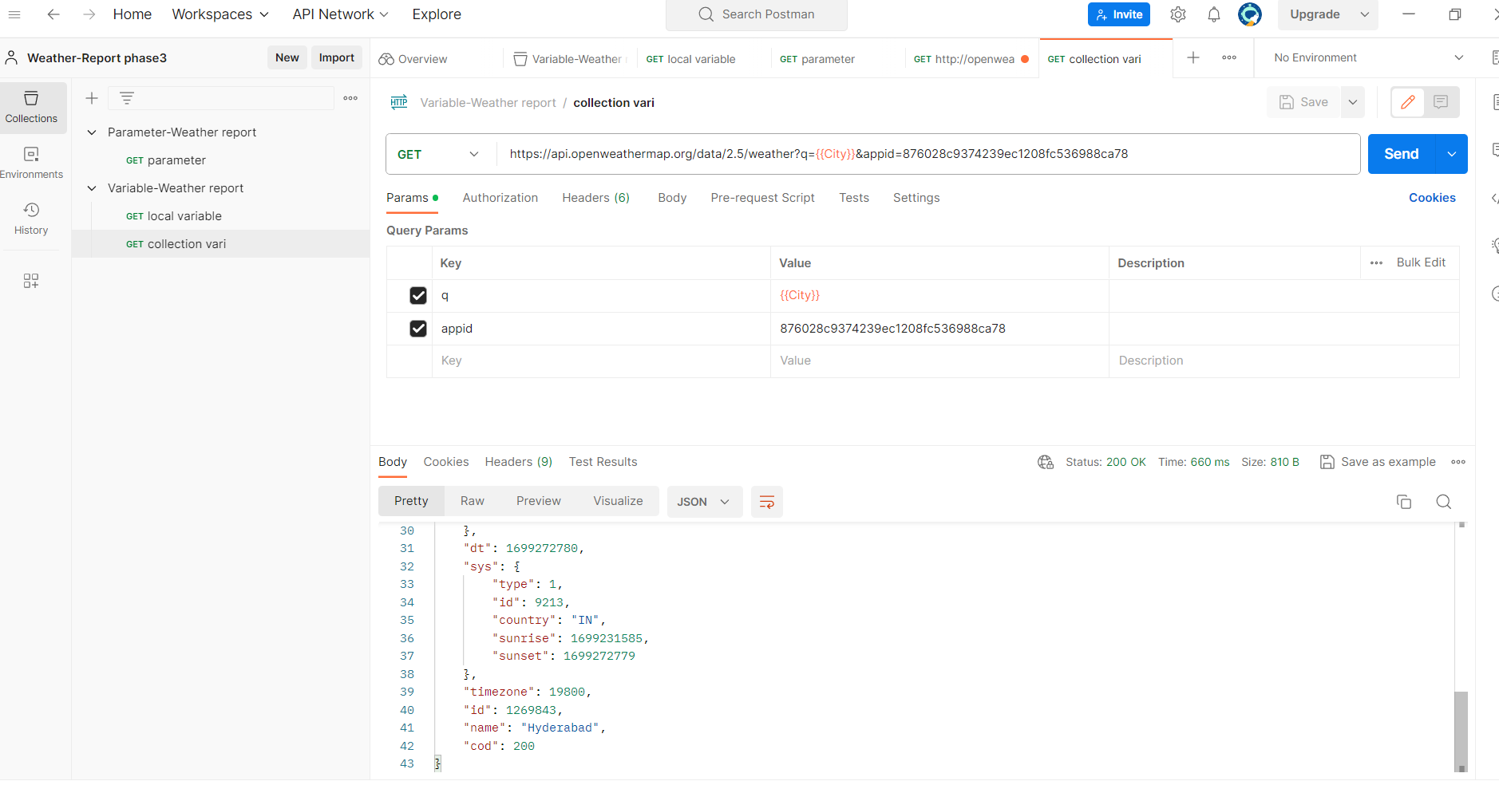

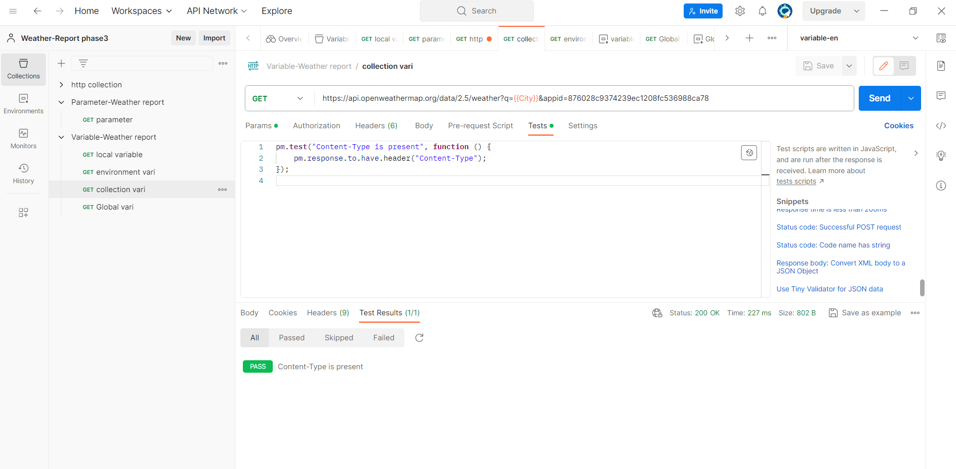

**Environment variable**

To add environment ,we added a request to collection,

Given name as environment vari.

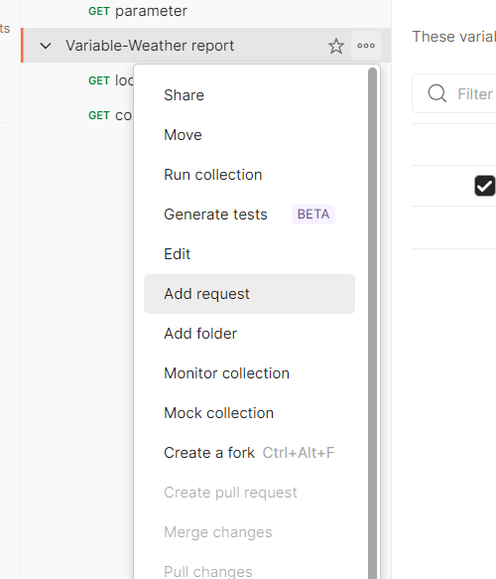

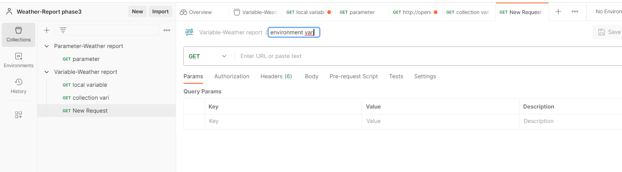

then click on the environments

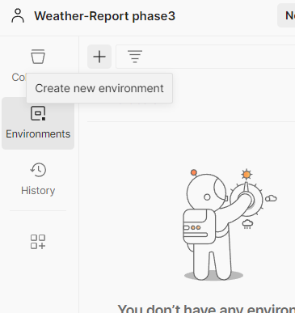

then added a variable to the environment

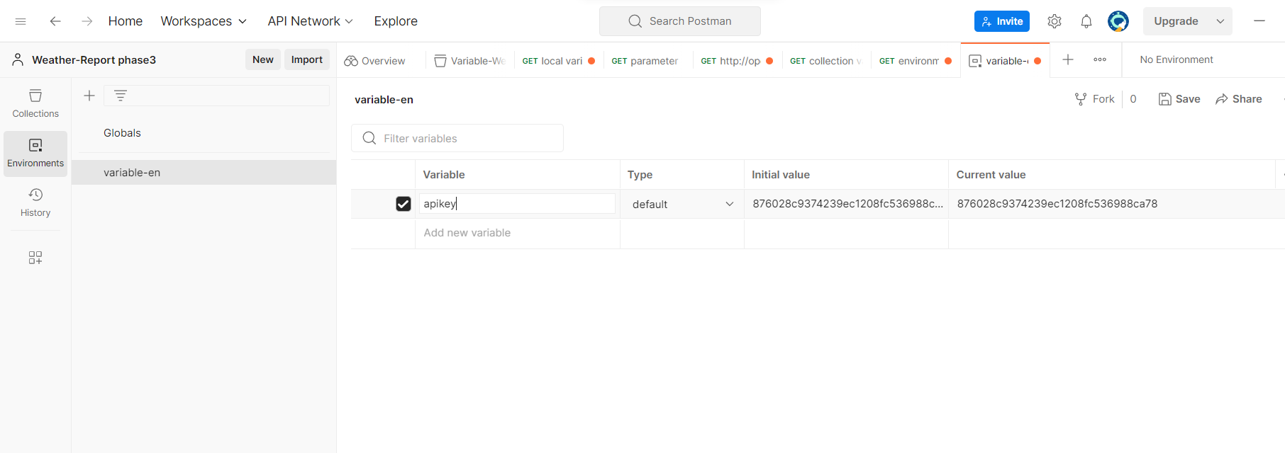

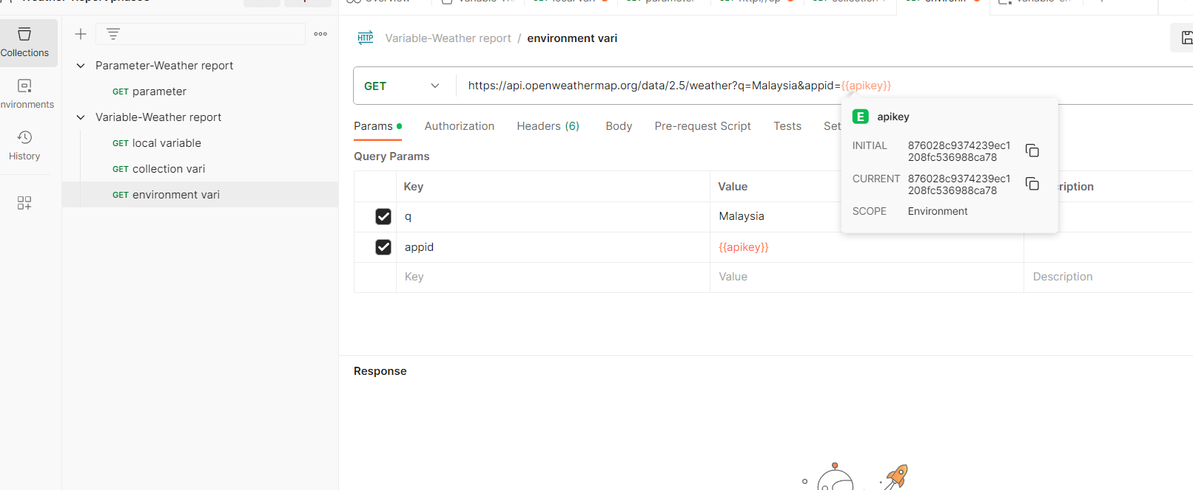

**Click on the send button to view the result**

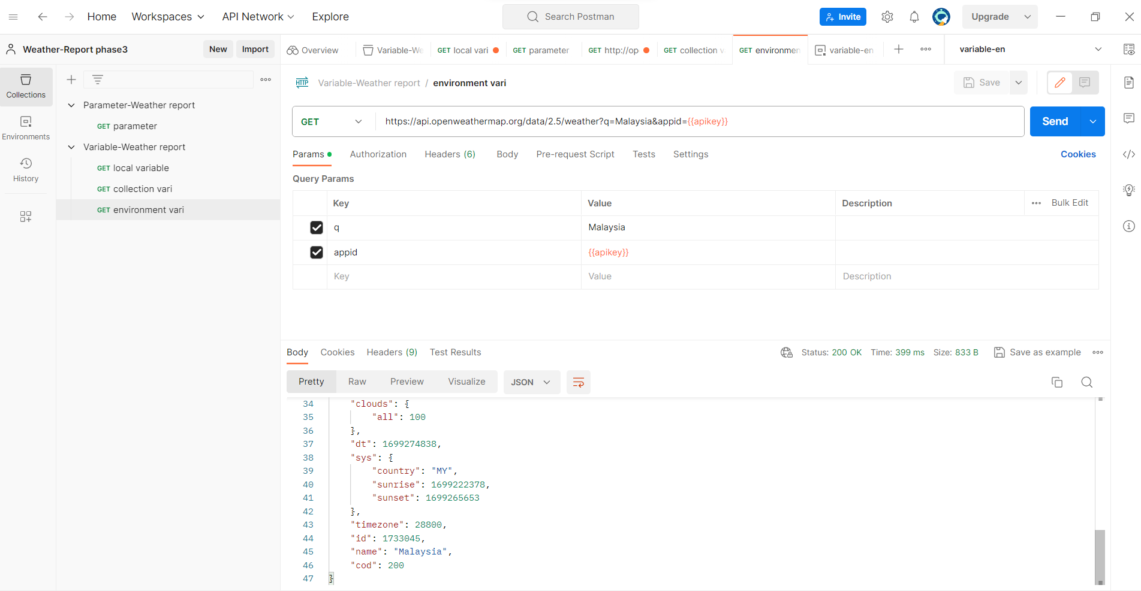

Global variable 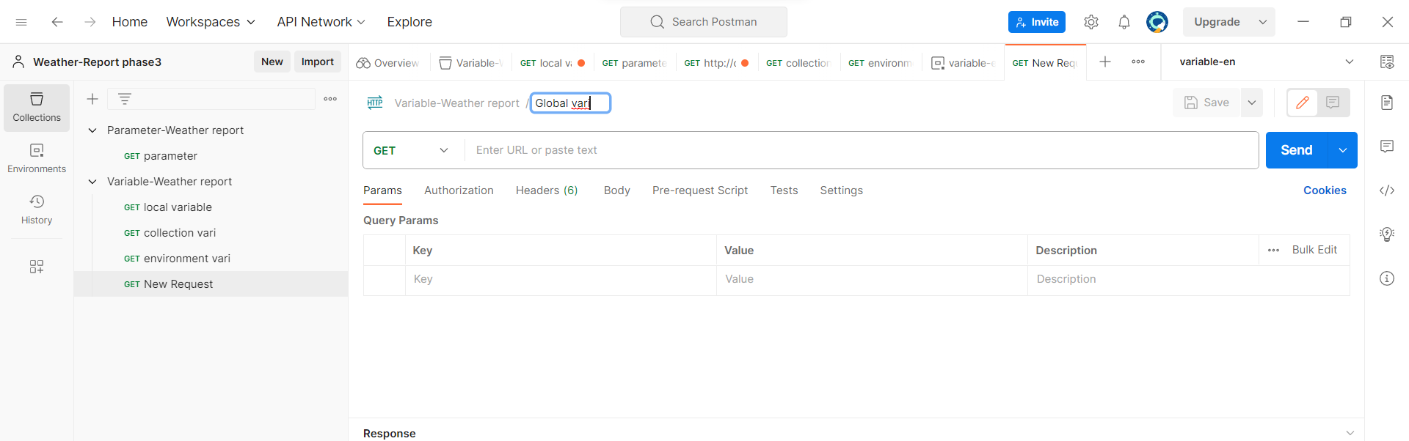

First click on environment then click on the global to add global environment which can access by any collection

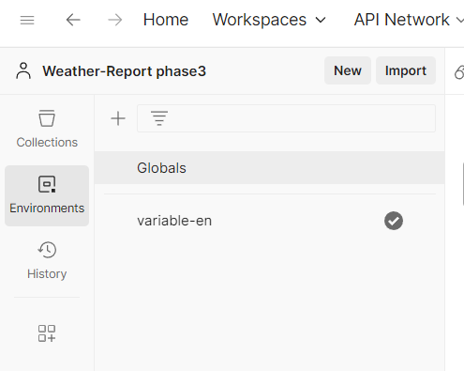

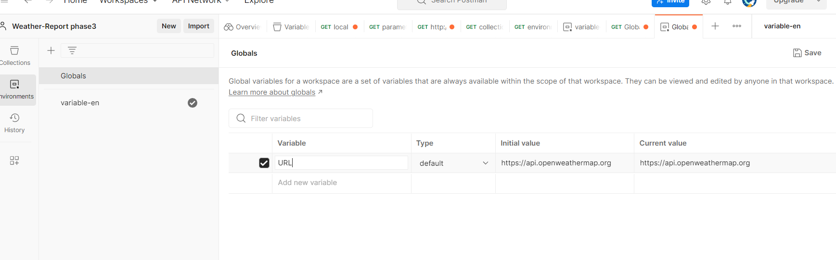

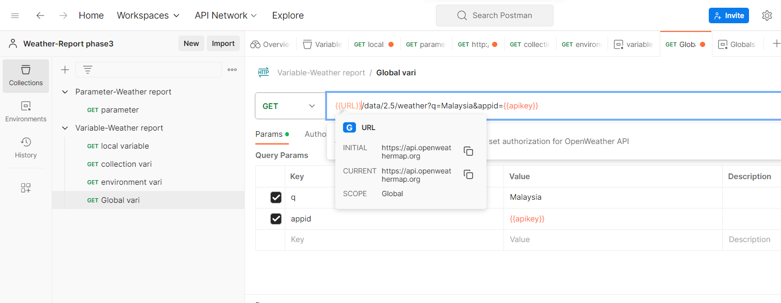

Then click on send button.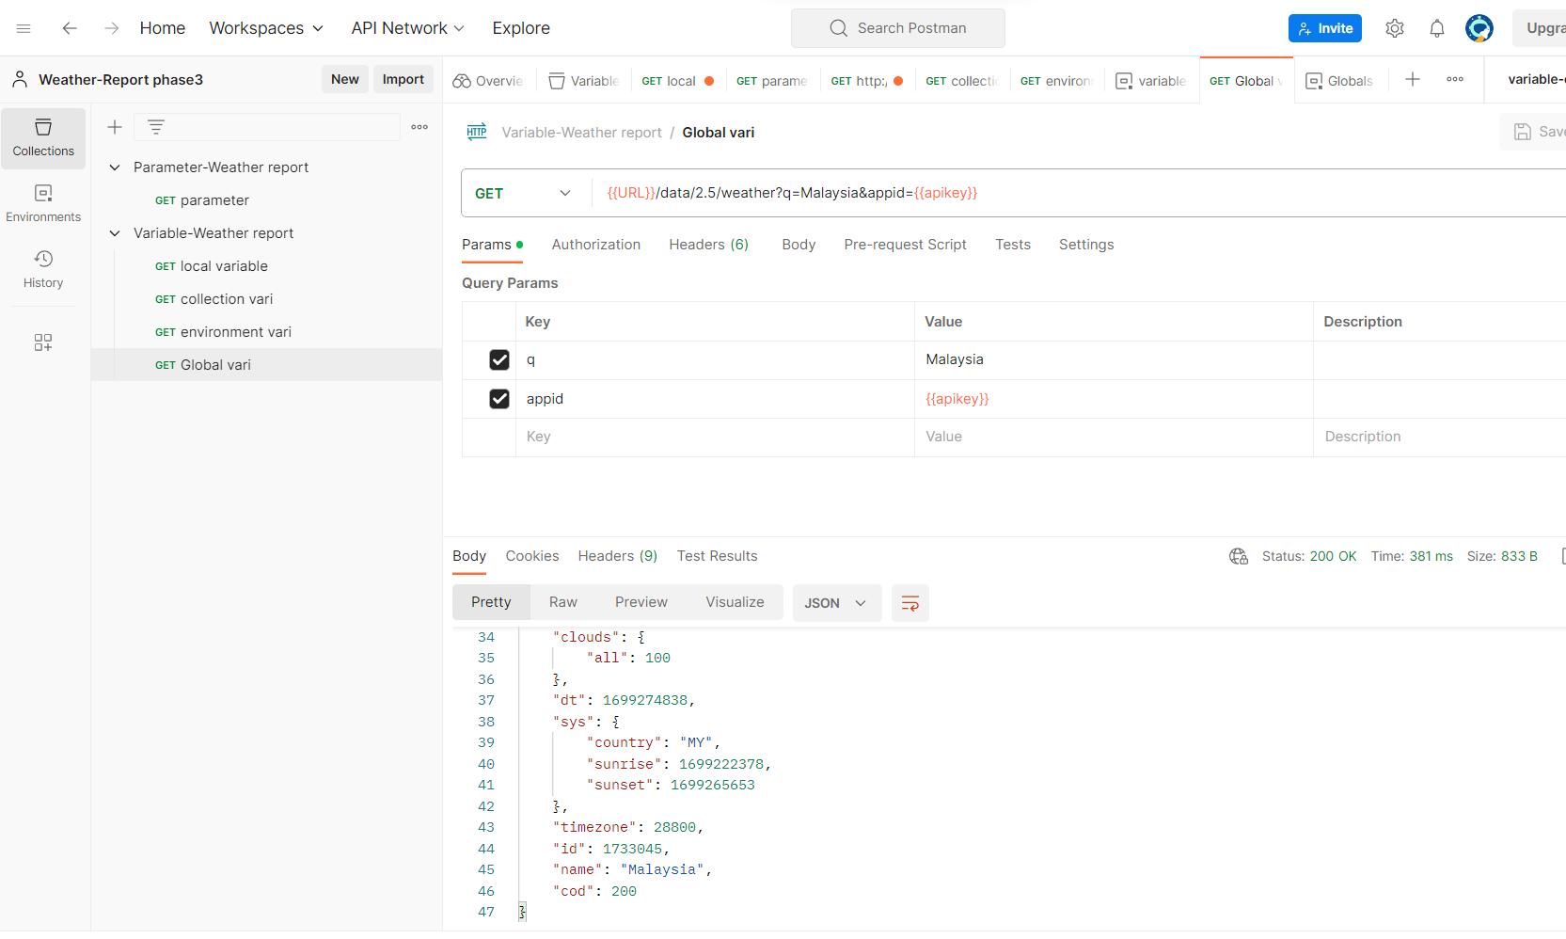

**To run the collection manually ,click on the three dots on the collection select the run collection option.**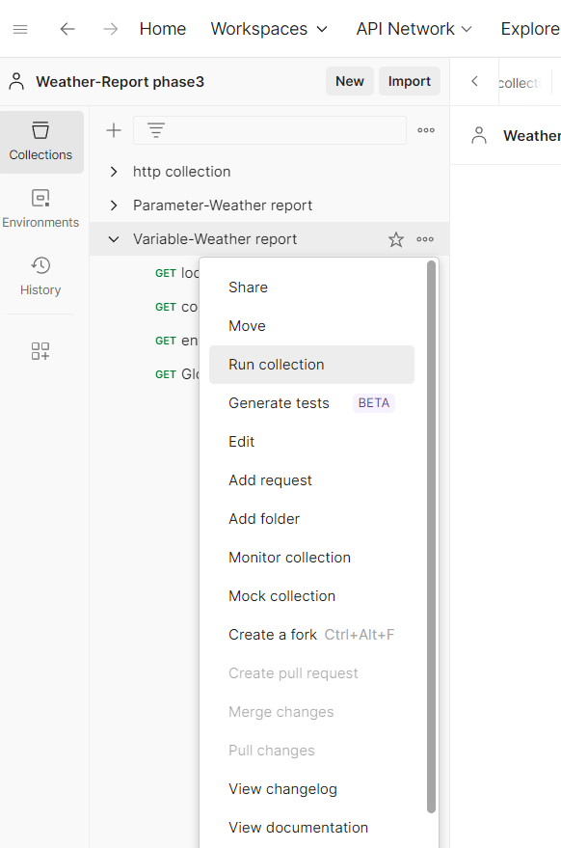

Select the request which you want to run ,and select the iteration and click on run variable to see the output.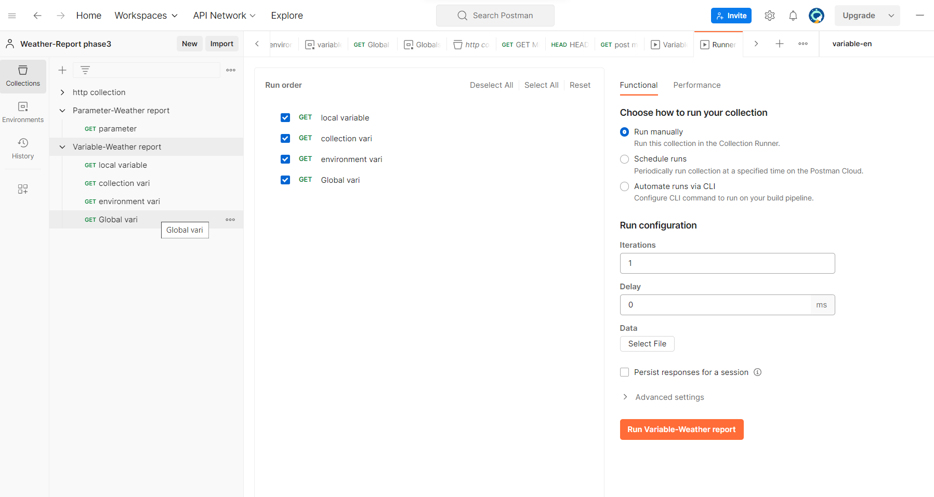

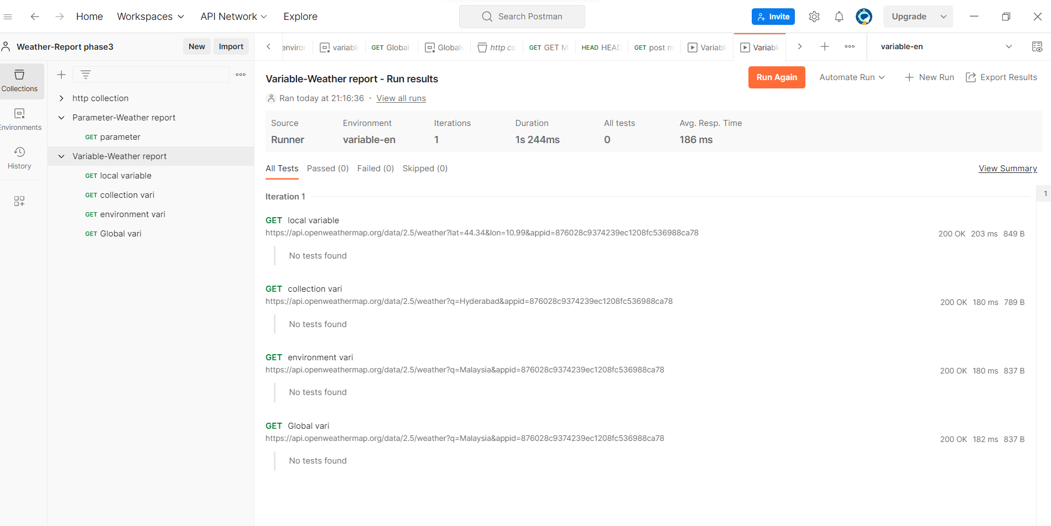

**To run the collection in local machine by command prompt via newman tool.**

Click on the three dot to the collection which you want to run in command prompt via newman and select the share button.then via api key .click on generate key and copy the key.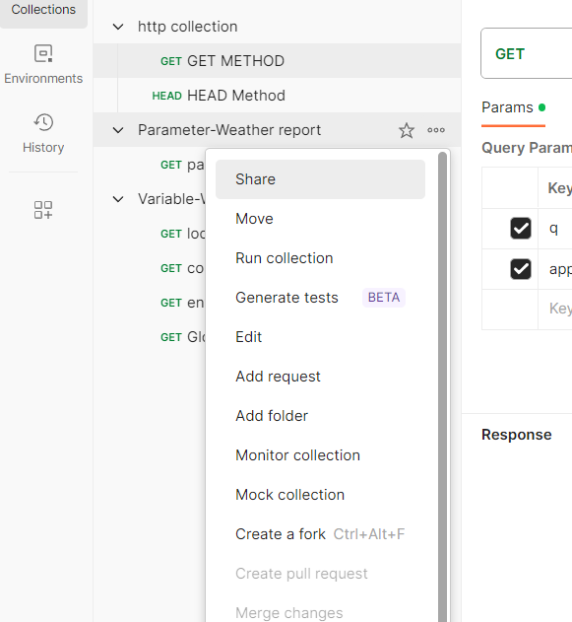

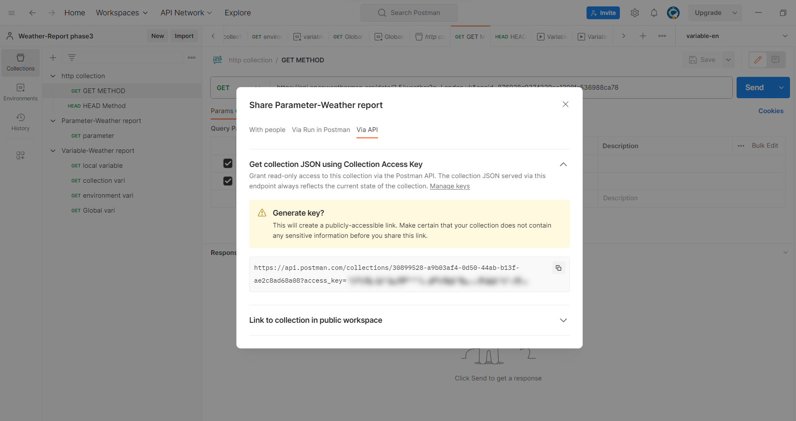

Then type the following code

Newman run paste the copied key.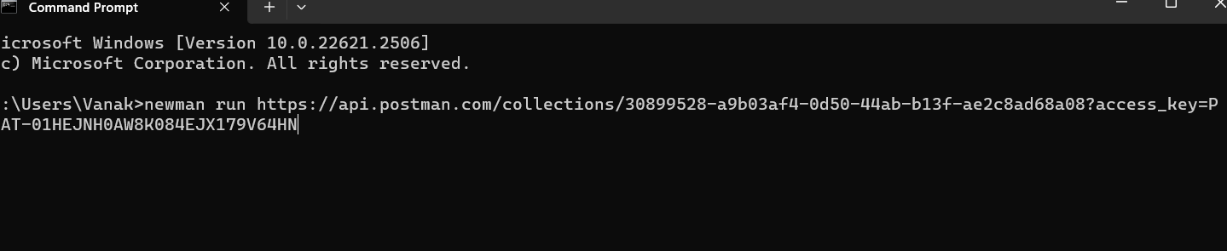

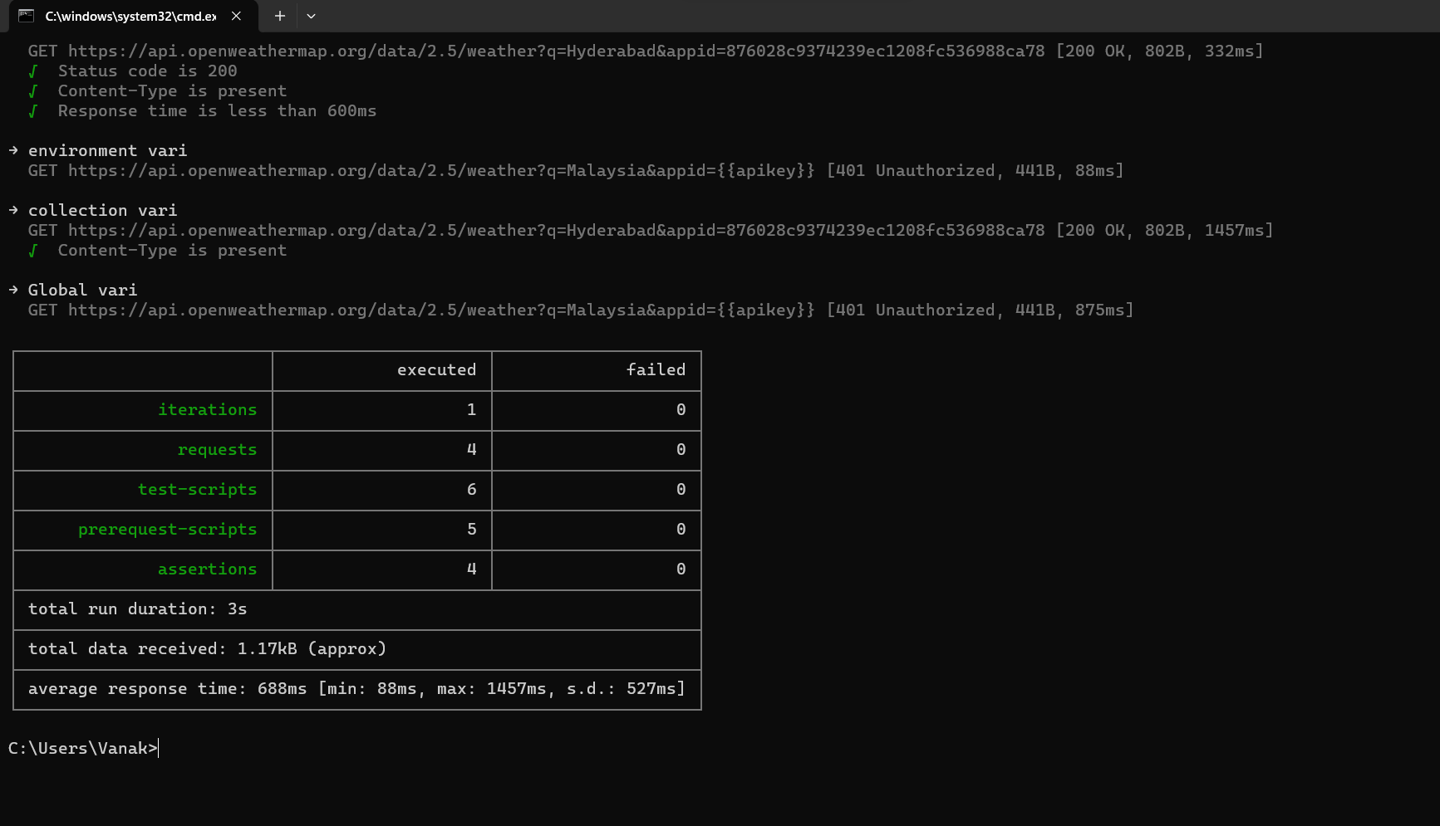

**Running collection via jenkins.**

Click on the collection and select the run collection,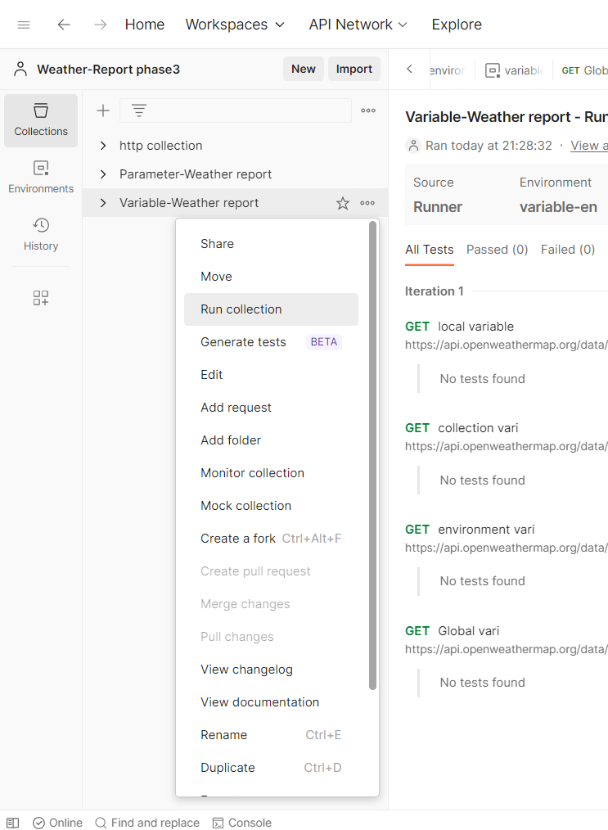

Select automate run via cli,then click on config setting.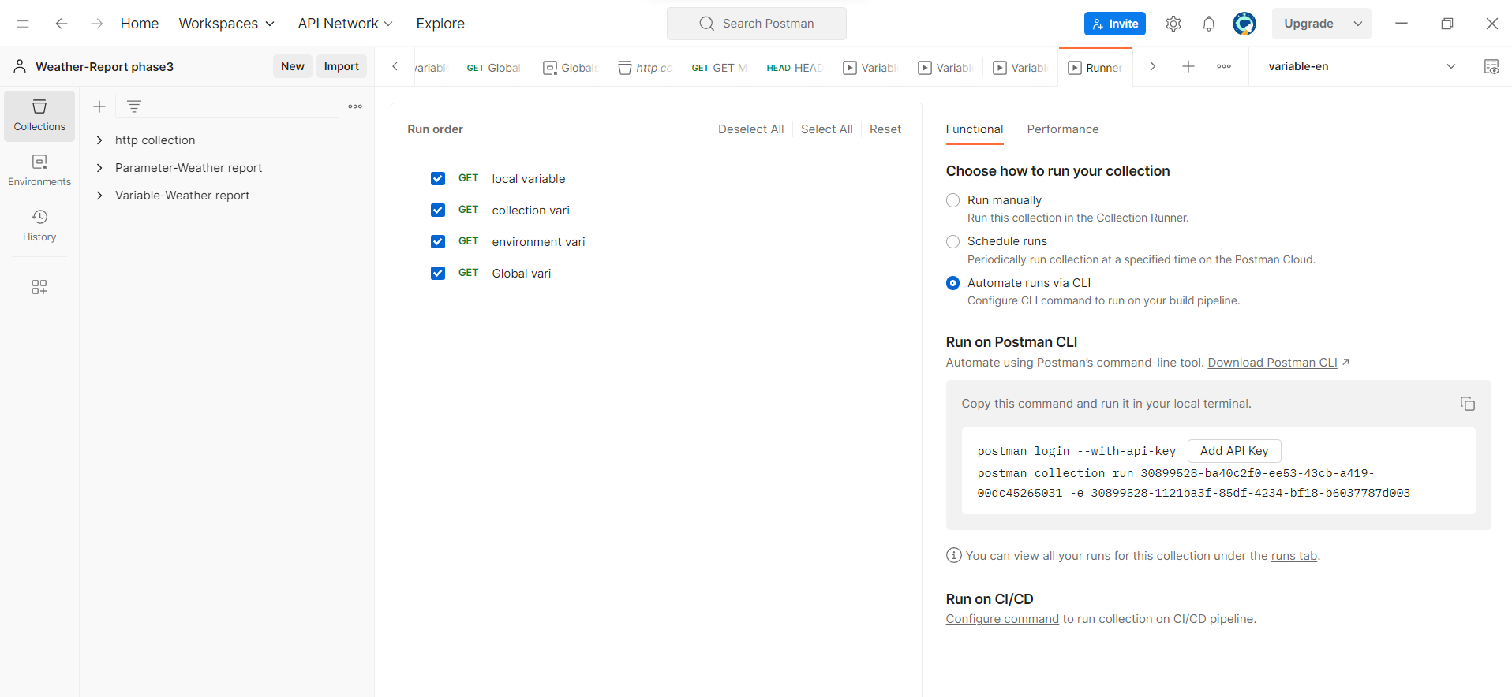

Select the variable and collection,system etc.

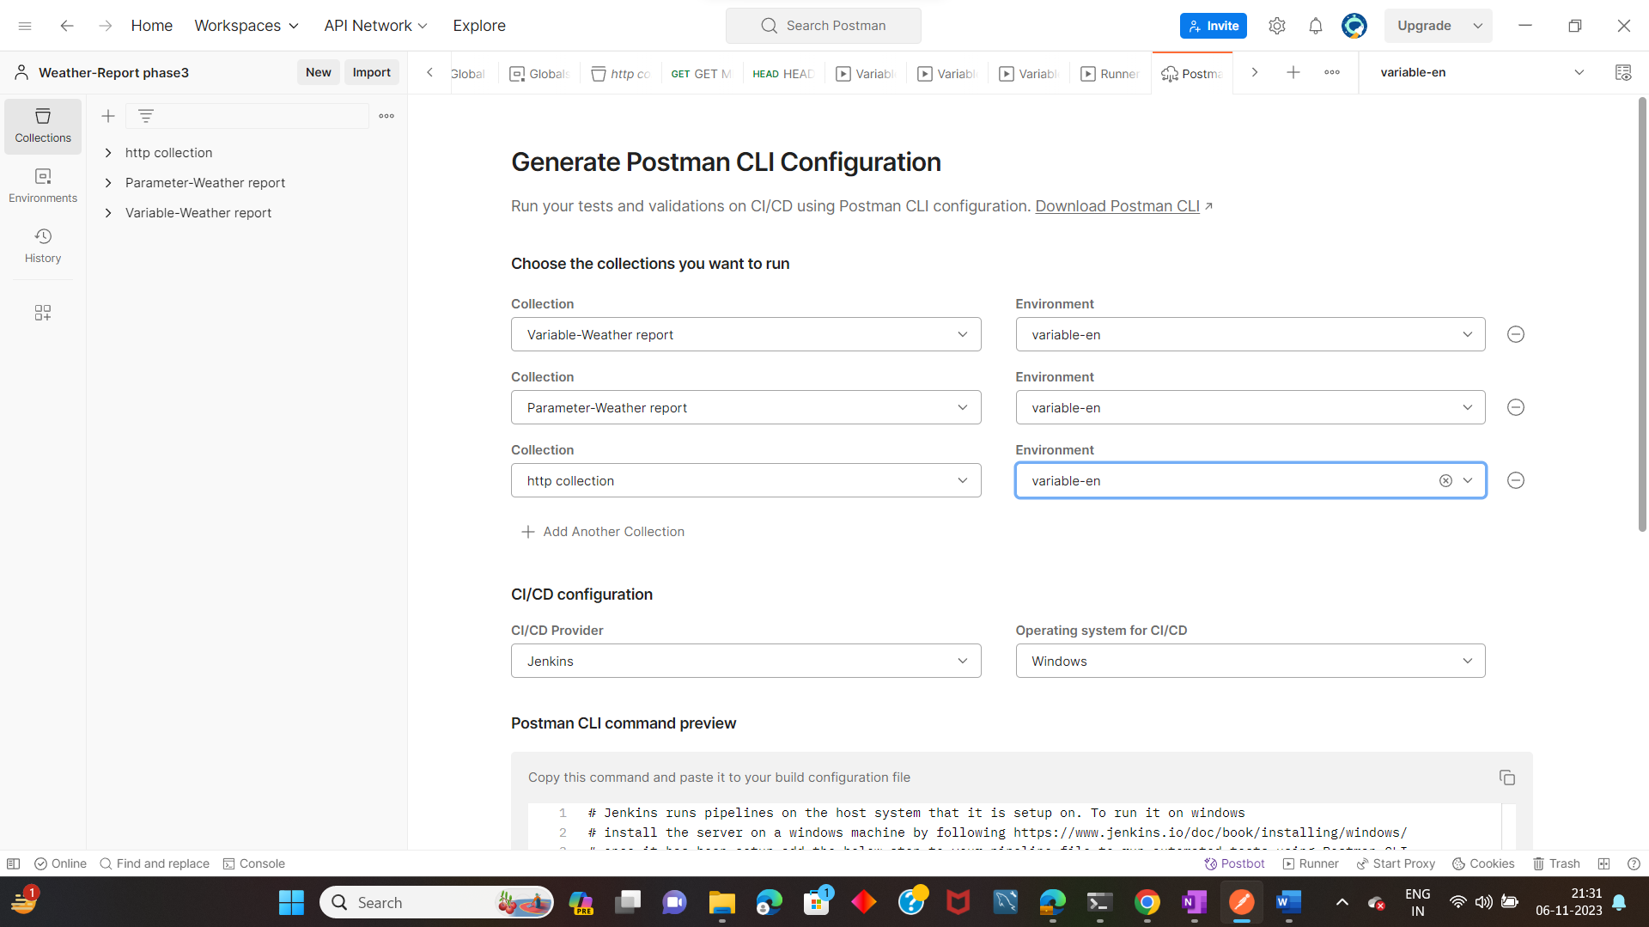

Copy the script 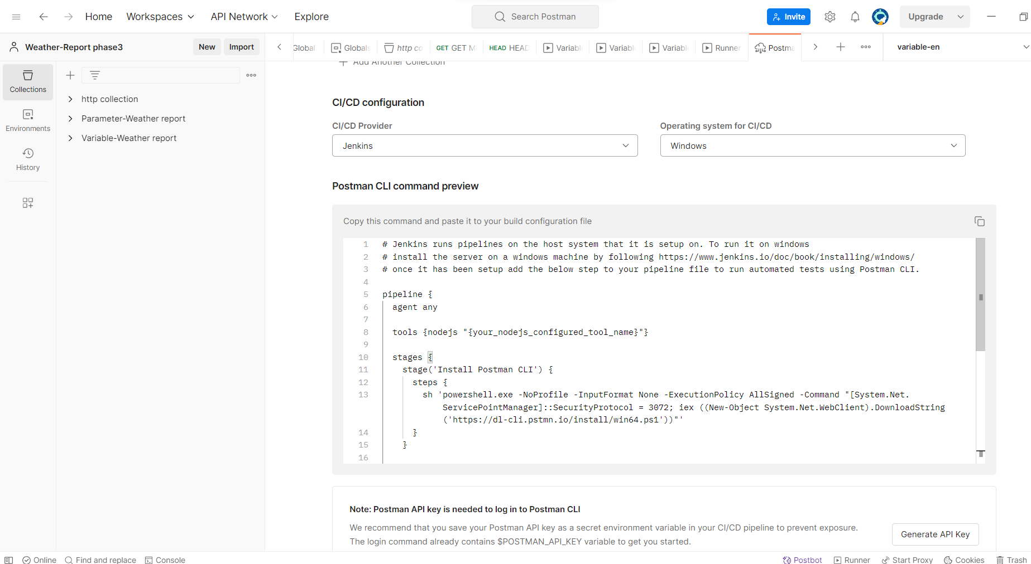

Create a new job in jenkins

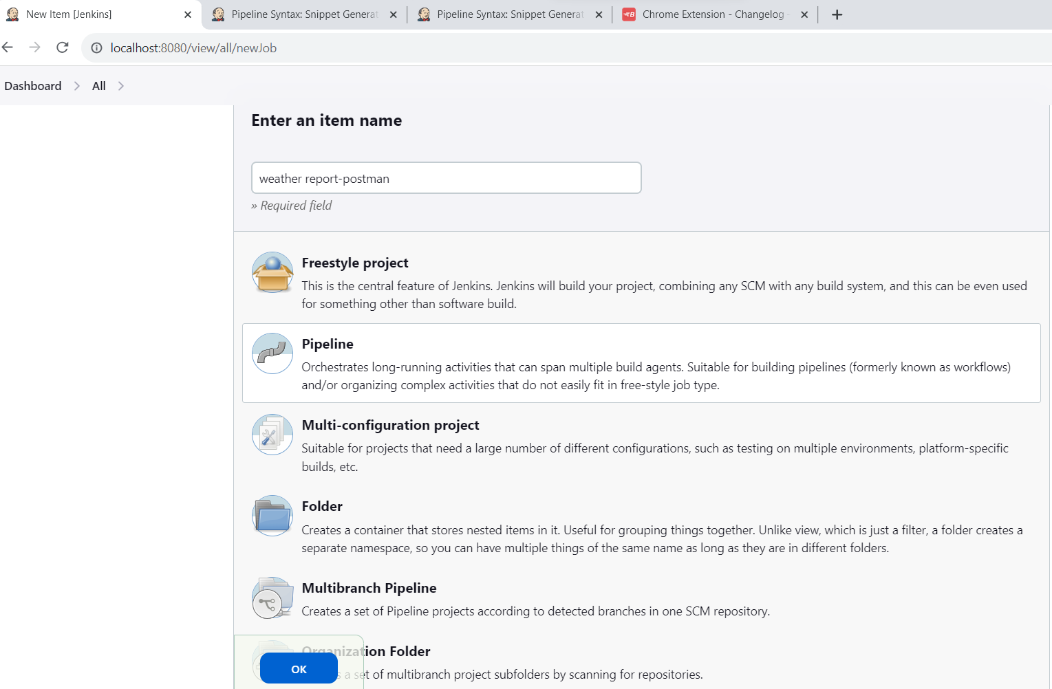

Paste the script in pipe line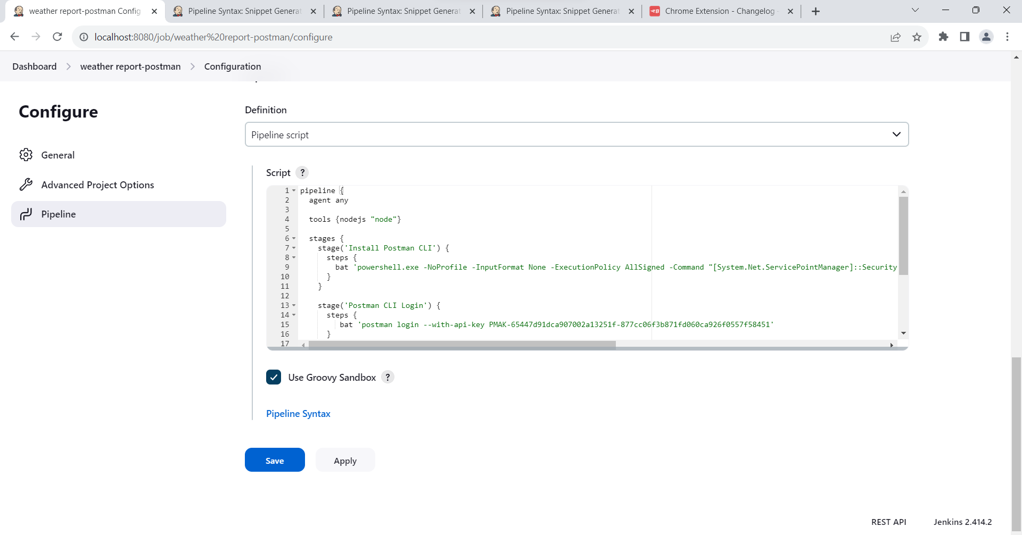

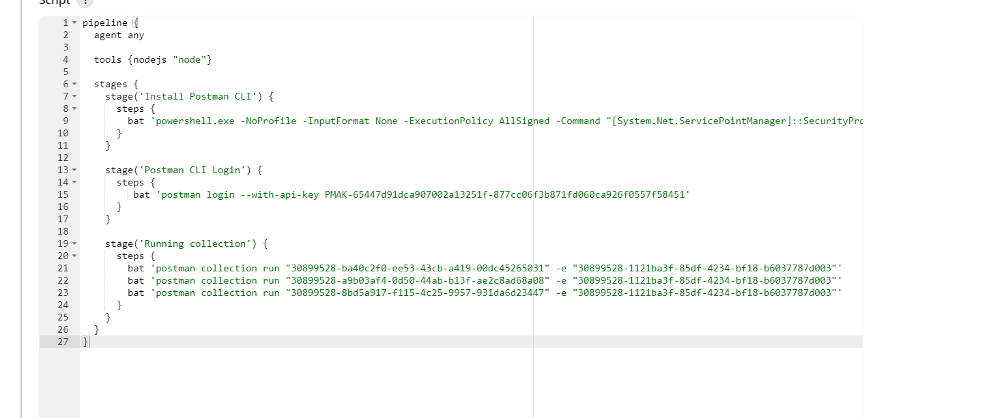

Click on build now to run the job in jenkin,you can see the output.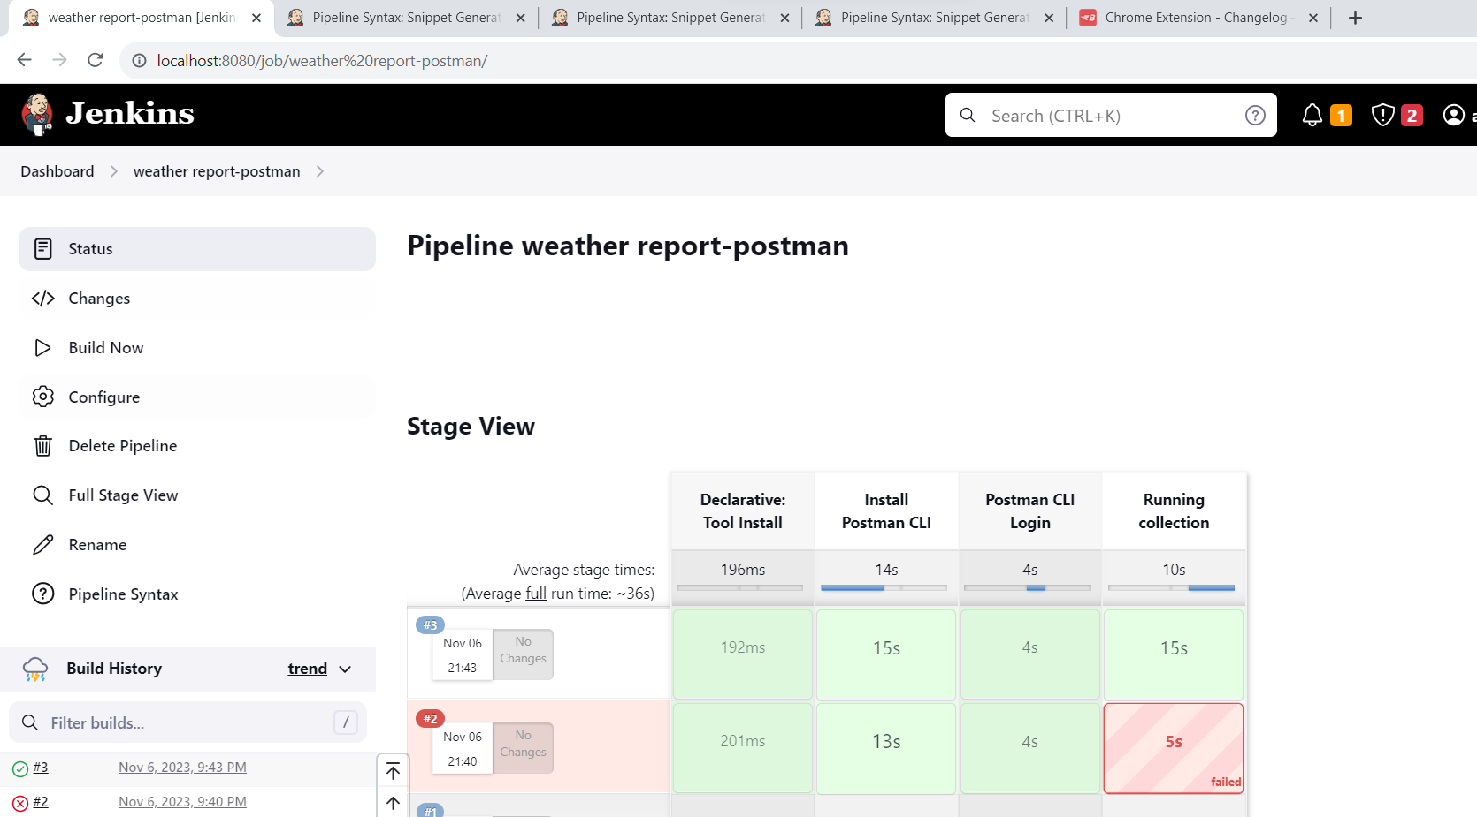

Running through monitor and csv data

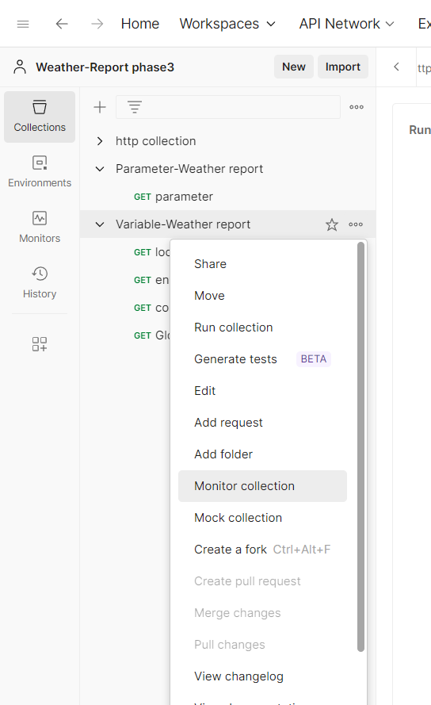

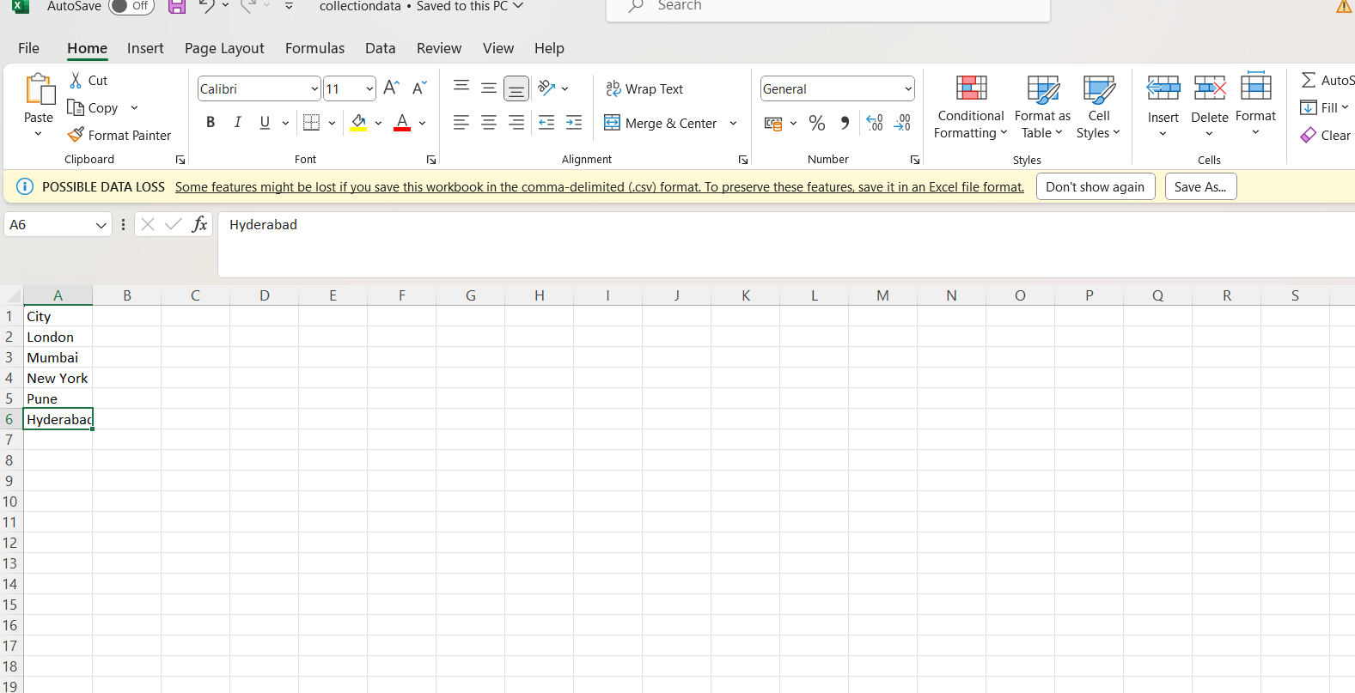

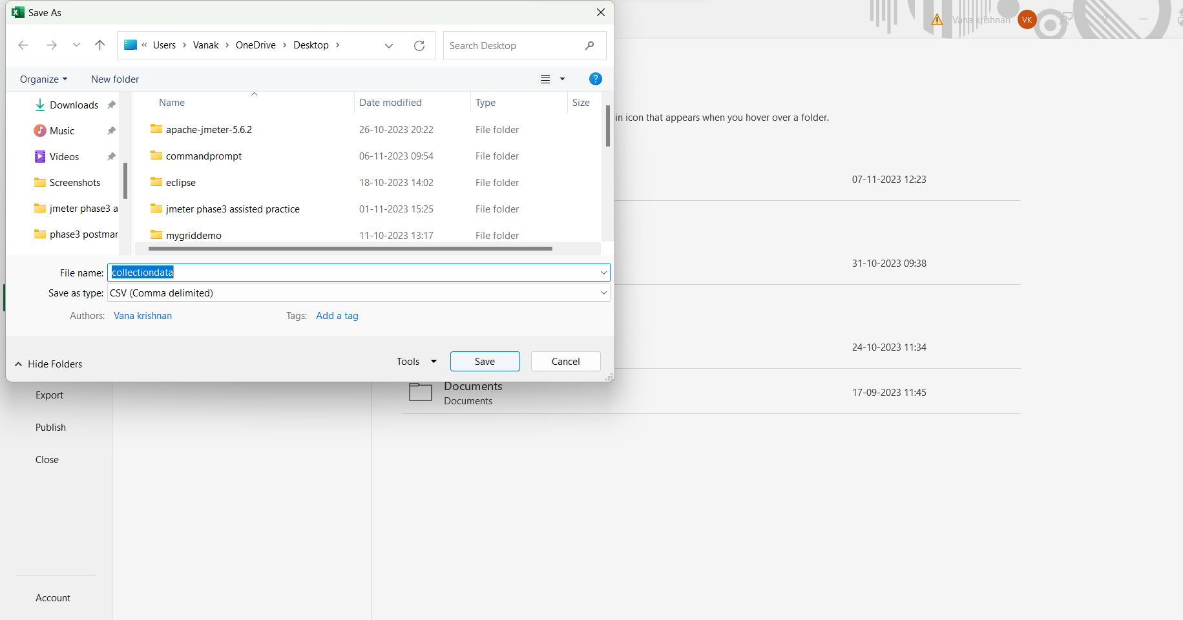

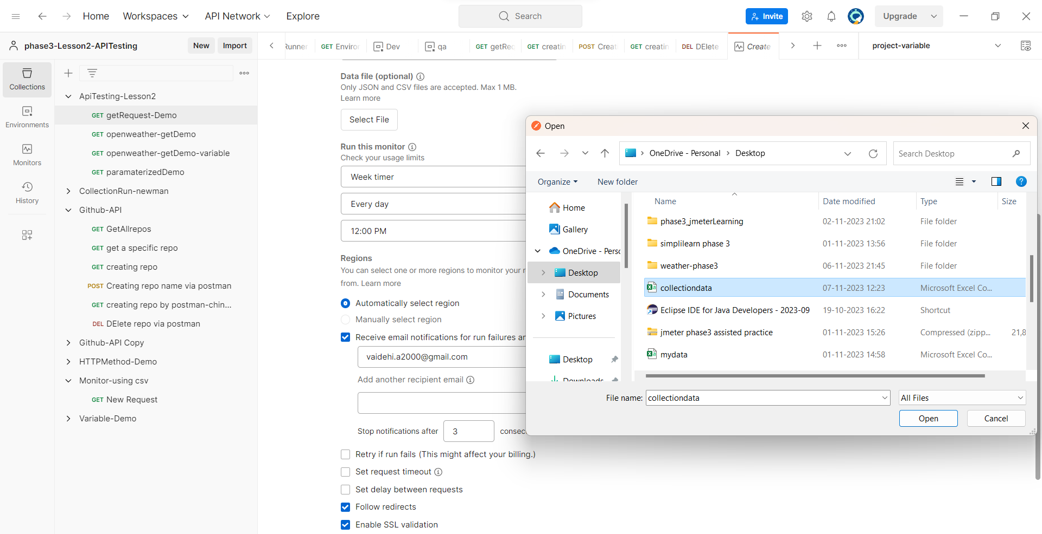

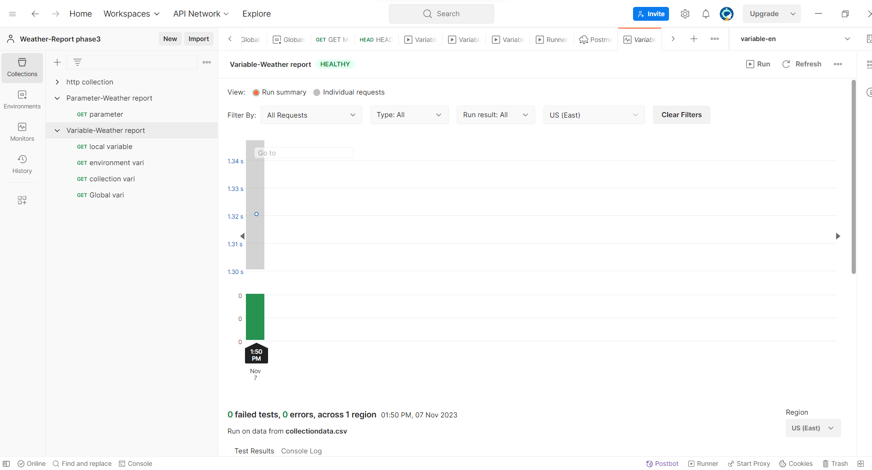

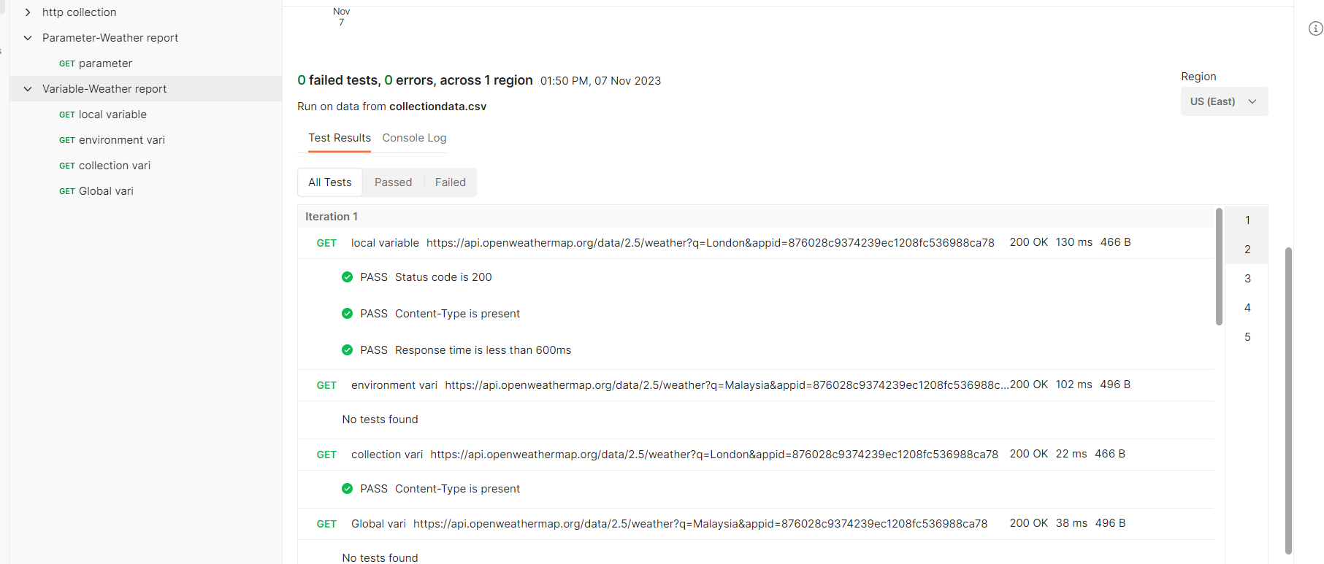

Adding a request giving methods as HEAD

Click on send button to view the result.

